**Pawn Broking Software**

Dsj MiniProject

Sec: G

III Semester

PESIT

Team members:

* Ahaan.R [1PI14CS011]
* Karthik Ravi [1PI14CS048]
* Pradyoth.S [1PI14CS070]

Project Description:

In daily life, when people are in need of urgent money, They rush to a Pawn shop to pledge their belongings and get money in return for a specific amount of time which they would return along with some particular interest rate.

The idea of our project was to incorporate this system into a working online software, Where clients can pledge their belongings, be it Gold, Silver or Platinum, specify its purity and other required fields after which the software would return the intrinsic value of that object depending on the PRESENT DAY VALUE per gram of that object.

It also tells the client how much loan would be given depending on the intrinsic value of that object and that is 75% of the intrinsic value.

Once the client chooses the time period within which he would like to return that object, the total value to be returned will be calculated. That includes the total loan value + interest.(for the number of days)

Data Structures Used:

The Data Structures used in this project are **Singly Linked Lists.** Every client who wishes to pledge their belongings will have a singly linked list of the items they would be planning to pledge. For example, If client X wishes to pledge his Gold Watch, Silver bracelet and a Gold chain. A singly linked list of these objects would be created for that Client X.

There will be several such singly linked lists created depending on how clients are pledging their objects.

Tools Used:

Apart from Linked Lists, We used **JAVA FX** for the GUI.

We learnt a few concepts from YouTube to incorporate this into our project.

Design:

Customers Details Input

Items to be pledged

Enter Details Of the Items

input Time Period

Display Item List

Compute Value-Display amount given to customer

Remove item- YES/NO

YES NO

Enter id of item to remove

Final agreement

Remove Item

Screenshots:

These are a few screenshots of the input fields created using JAVA FX.

1]

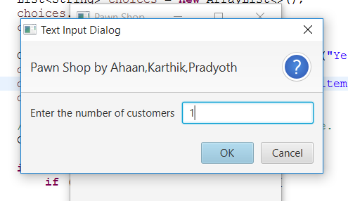

2]

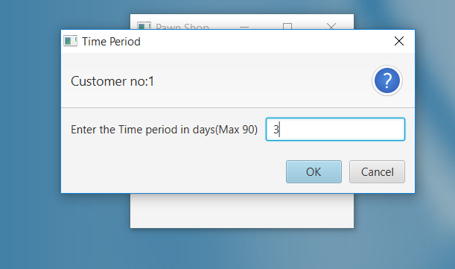

This is the output which is displayed once all the fields are entered.

3] 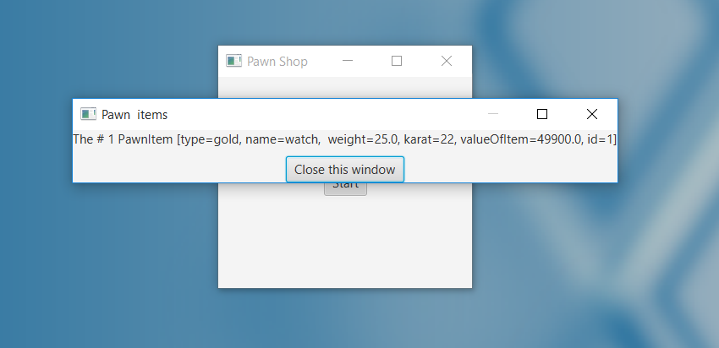

Conclusions:

We would like to conclude that this project made us strengthen our foundation concepts as well as learn many new concepts.

This also helped us learn how theoretical concepts are implemented in the real world scenario’s to help improvise the facilities provided to people by bringing it to their computers through the internet.

We did face a few difficulties when we had to incorporate JAVA Fx along with the DSJ code.But,we did overcome this with the help of our faculty teachers who were willing to help us at every step.

We are planning to improve it by adding a few more fields apart from precious stones,which will make it more flexible for many more clients.